**CHALLENGE 2**

Please refer to the schema below & follow the instructions to complete the exercise

**Duration: 1 HOUR**

**Objective: To be more confident using DML & DDL**

# Movie Rental Information System

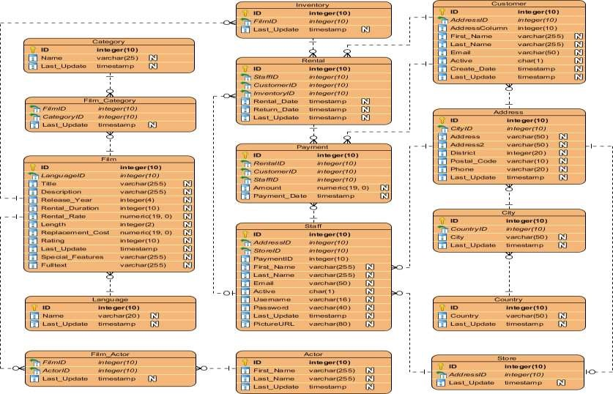

**Instructions**

SQL statement

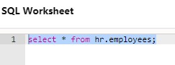

Output

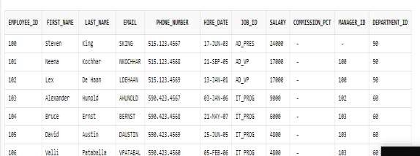

# Questions

1. What the candidate keys for below the tables

|  |  |
| --- | --- |
| Customer | ADDRESSID,EMAIL |
| Rental | STAFFID,CUSTOMERID,INVENTORYID |
| Film | LANGUAGEID,TITLE |
| Staff | ADDRESSID,STOREID,PAYMENTID,EMAIL,USERNAME |

1. Identify the primary keys

|  |  |
| --- | --- |
| Table Name | Primary Key |
| INVENTORY | ID |
| ADDRESS | ID |
| CUSTOMER | ID |

1. What is a composite key? Is it applicable for the ER Diagram shared?

A composite key is the DBMS key having two or more attributes that together can uniquely identify tuple in a table.

1. 4. Identify the foreign keys of the tables

|  |  |
| --- | --- |
| Table Name | Foreign Key |
| CUSTOMER | ADDRESSID |
| ADDRESS | CITYID |
| CITY | COUNTRY |

1. How do you justify Address as a separate table?

CREATE TABLE ADDRESS(

ID INTEGER(10)PRIMARY KEY,

CITYID INTEGER(10),

STREET_NO VARCHAR(50) NOT NULL;

AREA VARCHAR(50) NOT NULL,

DISTRICT VARCHAR(50) NOT NULL,

POSTAL_CODE VARCHAR(50) NOT NULL,

PHONE VARCHAR(50) NOT NULL,

)

1. Is it great to have many to many relationships in ER Diagrams? Justify

Many-to-many relationships are disallowed in a relational database because of the problems they create. These include: Data redundancy. Data insertion, deletion, and updating difficulties.

1. Which columns in will have the following constraints?

|  |  |  |  |
| --- | --- | --- | --- |
| Table Name | NOT NULL | CHECK | DEFAULT |
| CUSTOMER –FIRST_NAME | 🗸 |  |  |
| STAFF -EMAIL | 🗸 |  |  |
| ADDRESS-PHONE |  | 🗸 |  |
| STAFF - STOREID |  |  | 🗸 |
| ADDRESS-POSTAL_CODE |  | 🗸 |  |

1. What is the key difference between primary key & unique key?

The primary key is accepted as a unique or sole identifier for every record in the table. In the case of a primary key, we cannot save NULL values. In the case of a unique key, we can save a null value, however, only one NULL value is supported.

1. Create table structures for all tables & describe command to check if you the tables are created
2. Add 5 sample rows to each table
3. Illustrate Modifying rows using Update Statement with examples.
4. From the ER diagram, Identify which columns /attributes – the users will be most searching for?
5. What are the various statements we learnt with the ALTER TABLE command? Take a table of your choice and Illustrate with SQL statements
6. What is the difference between DELETE & DROP Statements?
7. I want to update a film if it exists or add a new row in the same table. How do I achieve this using one statement in Oracle 9i or greater?
8. Which is faster – delete or truncate?